THE PHOENIX THAT ROSE FROM THE ASHES
A HISTORY OF OUR CLUBHOUSE
By Ray Davies
FOREWORD
On the 25th of June 2023, at their annual Barbecue and Social Evening, Lymington & District Sea Fishing Club celebrated the 30th anniversary of the building of their clubhouse.
As I was heavily involved in this project over many years, I have been asked to put pen to paper to explain how it all came about, when it was built and why, so that both the old and newer members will be aware of the history of the club.
Firstly, let me briefly introduce myself for the benefit of those newer members who do not know me and the reason for taking on this task. My name is Ray Davies, and I joined the club in 1954 as a junior member at the young age of 14, the first junior elected to the committee to represent the other juniors of the club, of which at the time there were many. I continued the next 48 years or so in many various and important positions of the club, the last being treasurer for approximately 25-28years, leading on to the project of the clubhouse. It must be said, though, it would not have been possible without the help, belief, and dedication of many others, both members and friends, who put in many hours to enable this building to be completed and which is now well established in the fishing fraternity.
As much of what I am writing about is from memory and from what records are available, I apologize to anyone whom I have not mentioned but who nonetheless contributed in some way or another to this establishment - or as I like to call it, ‘The Phoenix that rose from the ashes.’
To understand how this project originally came about and why, some understanding of the club’s history is necessary to fully realize that from its original inception, the club had evolved to such an extent that in my opinion the need for a permanent base had become ever more evident if we were to progress at all.
CHAPTER ONE
When The Seed Was Sown
The club was formed in 1936 by 10 anglers who mainly came from Milford-on-Sea. They met at the ‘Rising Sun’ in Wootton, near Bashley, and for some reason (still to be discovered) called it the Lymington & District Sea Fishing Club - although the Milford-on-Sea Fishing Club would seem to have been more appropriate! The club thrived and grew in numbers until the war came along in late 1939. Activities were suspended until 1945, when they were restarted.
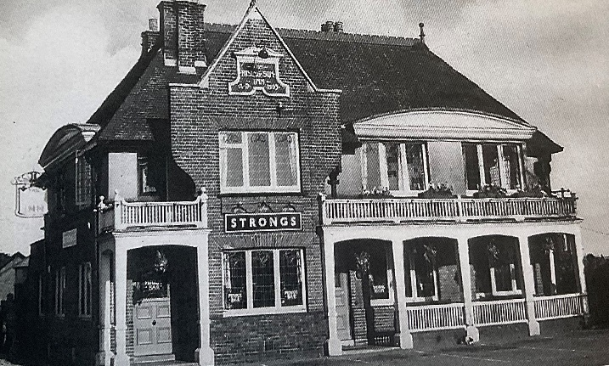
The Rising Sun, Wootton.
Between 1945 and 1954 (when I came along) the committee meeting place had changed to the Solent Court Hotel, on Hordle Cliff, owned by a Colonel Reddy, who became a vice-president of the club. By now the club had grown with a much larger committee than the original five; and with more things to do. We met then, as is now, on the first Monday of the month at the Hotel in the Games room, sitting around the table tennis table. At the time the committee consisted of Ron Hann, Secretary; Mrs Hann, Assistant Secretary; Ted Tuckerman / Gerald Ashton-Smith, Boat Commodore; Ernest Britton, Docket Steward; Denis Curtis, Treasurer; Ken Baveridge, Frank Hamblin, and several others.
The hotel was eventually demolished to make way for redevelopment, and future meetings were held at various venues over the years: The Hearts of Oak pub Lymington (since converted to residential use); Pennington Sports & Social Club, Pennington (twice); The Wheel Inn, Pennington, The Londesborough Hotel, Lymington (since converted to commercial premises); and The Railway Hotel, Station Street, Lymington (now the Bosun’s Chair). Annual general meetings were held at The Angel Hotel, Lymington, and Lymington Community Centre, until in 1993 when our clubhouse was completed.
It was at one of these committee meetings at the Solent Court Hotel, when we were organizing our annual fishing charity event along Milford and Hordle cliffs that the question came up regarding equipment and who had what, as it was kept in various people’s homes etc. Nobody seemed to know exactly and I, being young and a greenhorn regarding club and committee work, quite innocently said, “If we had a clubhouse we would know.” At which the secretary Ron Hann looked up and in a very smug manner said, ‘If you think you can get one, then do it.’ From that point on I was determined to try and do just that and make it happen, not knowing how, when, or where, at 14 years of age, young and inexperienced. The seed had been sown, and the challenge accepted. The question was, ‘How was it to be done?’
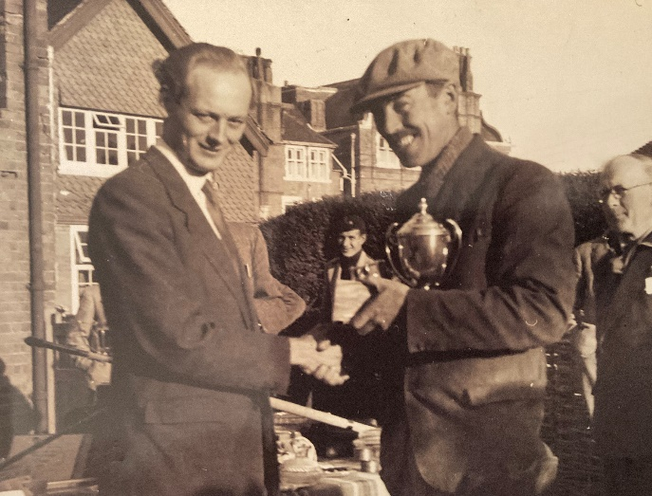
Vice-President Lord Montagu presenting prizes at the Spring Open circa 1950 outside the Solent Court Hotel. Den Head in the background with the beret and Ted Welland, Clerk of Scales, on the right.
CHAPTER TWO
Commitment & Funds
When embarking on a project such as this there are several things that can come into play.
1) Belief in the project.
2) How to do it.
3) Funds.
4) Support.
5) Where?
6) Luck.
1) First of all, belief in the project was my strength and fishing my overall passion. No matter what the obstacles were I firmly believed that as a club with determination, it could be done somehow. All that was needed was somebody to drive it and convince others to help and to work as a club to achieve it. It turned out that at the time, if this was to be done, it had to be me. The club was set in its ways; I had suggested it and so I took on the challenge. With this in mind, I felt that over time and with the help of those who already were of like mind, although few in number, I could persuade the committee to follow me.
2) In order to achieve this, I felt that a building fund was needed; not only to ring fence any revenue raised for this project, but also to act as a goal for everyone to aim at. This I hoped would then convince most people that as time went by, it was achievable. My hope also was that as the revenue grew it would make members even more determined.
3) On this basis the first task was to get the committee to agree to opening a building fund and then start raising money for it, which I managed to do. But I had to convince the treasurer (Denis Curtis) it was possible as well, as he, being a sceptic on the issue at the time, (although coming onboard later) was not enthusiastic and did not rush into doing it.
Slowly and surely, whenever we held any fishing events, I managed to get the committee to put some of the profits into the building fund. The first entry was seven shillings and six pence. This was when our currency was 240 pence to the £1. At the time it was a very small amount in what was the overall scheme of things - but the first brick had been laid.
4) The fund started to grow. In October 1966 the fund had reached £8.14.6d. And by November 1970 it had reached just short of £900.
I was elected Treasurer in 1971 and at committee meetings I ensured that the case for the building fund was raised whenever possible. At the same time more and more committee members/ members’ wives/ friends etc., became involved with fund-raising, especially for a clubhouse. As the fund-raising continued, support grew from all directions, mainly through fund-raising events from the people involved, but also from donations, which I’ll explain later.
During the course of the following 30 years or so, in order to raise the sort of money that was maybe going to be needed, we did all manner of things in order to raise revenue; nothing was ruled out: fishing competitions, draws (whenever possible), jumble sales, wastepaper collection, 18-mile sponsored walks, cake stalls, fêtes, beetle drives, bingo sessions, dances, carnival stalls, B.B.Qs, treasure hunts etc. All these events over the years raised the grand sum of approximately £30-£34,000 towards the clubhouse.
5) Having now a lot of support and some new committee members, questions regularly came up regarding the type of building and where to site it. Of course, this was bound to happen as there was now the money available, but we were still not able to answer them. Nevertheless, the reply given was always the same: ‘Somewhere near the water and what we can afford at the time.’
6) Probably the most important thing required: luck. You can plan and make most things happen but in the end lady luck has got to be on your side. As you will see there are different types of luck: bad and good. And as we progressed on this journey, we encountered our share of bad luck - before it finally turned.

CHAPTER THREE
Ups & Downs
During the years of fund-raising, the club was always looking out for opportunities of possible places, land or anything that may have given the club what it so desperately was working for: ‘its own premises’. We were now in the position of not only raising funds in earnest but also members and the committee were now all trying to find something that would achieve just that. There were numerous times when we contacted the local authority with requests to see if they could come up with something, like an area of land that we could maybe buy or rent from them to put a building on. The answer was always the same: ‘Sorry, nothing”. On one occasion they did say they might have something in Sway, which we declined as it did not fit in with our type of sport: we needed to be close to the sea to operate properly and the only area we deemed to be suitable was somewhere around the Bath Road car park area.
On another occasion a suggestion was made by the Council as to whether we would consider sharing a building with Lymington Rowing Club, who had similar problems to ours. We took up the offer and a meeting took place with them, and the idea was investigated, and plans submitted in 1981. It turned out that the area suggested, opposite the present R. N. L. I. building was a pumping station and balancing pond and disappointingly, planning could not be given for various reasons. Ironically, it was later made into a dinghy park for the Royal Lymington Yacht Club!
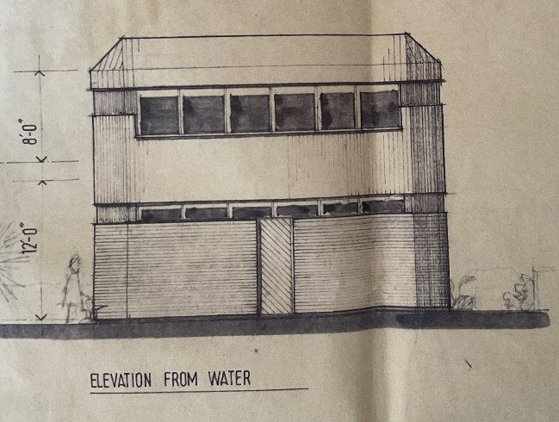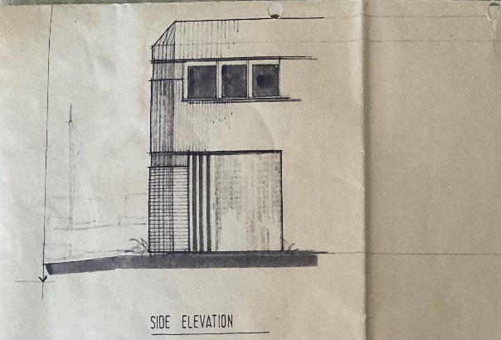
Proposed shared building with the Rowing Club.
However, there did occur what seemed a very good possibility of something when, out of the blue, it came to our knowledge that Ridgeway School was being demolished. An old wooden sectional classroom needed to come down and if anyone would dismantle it and take it away, they could have it. We seized the opportunity and with all hands to the pump, did just that. We stored it on some farmland where a club member worked with the idea that someday we would find somewhere to re–erect it. Unfortunately, at the time nothing could be found and eventually it was sold off for use as a stable.
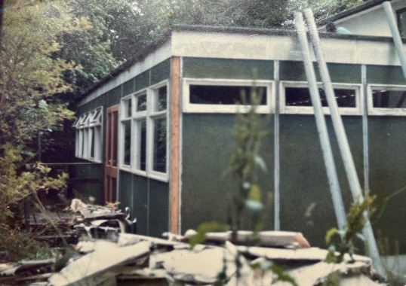
Classroom from Ridgeway School.
When Alec Harmer joined the committee in the early 1980s no further progress had been made regarding a clubhouse. He volunteered to resurrect the search and approached Whitbread in October 1985 with the idea of erecting a headquarters in the rear garden of the Mayflower public house.
Around the same time, one day in 1986, Alec and I were looking at some land on the west side of the car park (where our entrance to the clubhouse is now) where a donkey was tethered, grazing. I happened to say I wonder who owns that land and Alec replied that he thought it was New Forest District Council. It transpired that this was indeed the case. As far as we were aware no other club had expressed any interest in the land at that point. We approached New Forest District Council and were informed the proposed rental would be £700 on an annual licence. This meant that without the security of a long lease, any building that we erected would not attract grant aid. Nevertheless, we applied and were granted a 3-year temporary permission in October 1986; at its expiration, any building had to be removed. The reason for this limited period was that the Council might require the site at a future date, for example, extending the car park. We deferred any action in respect of our permission as our negotiations with Whitbread were still ongoing. Things seemed to be quite promising until the company informed us in August 1987 that the person whom we had been in negotiations with had absolutely no authority to make any such decision and our request had been refused.
We then discovered that in the meantime the Council were proposing to lease the field to the Royal Lymington Yacht Club even though we had an active outline planning permission on the land. Word had obviously got around and soon, along with The Royal Lymington Yacht Club, Lymington Town Sailing Club also approached the Council wanting some of the land. The plot was subsequently divided into three, with us being allotted the worst area, close to the houses on the north side of King Saltern Road, which would have needed a lot of clearing. Despite the disadvantages, for example, lack of security of tenure, high rental, the possibility of having nowhere to relocate any building which we had purchased if we had to vacate the site, we decided that we were going to lose out completely if we did not accept. Little did we know at the time that the Council had done us the biggest favour possible!
We obtained a further outline permission in November 1988, expiring in November 1990, to erect a headquarters. Rather surprisingly, the Environmental Services Committee, who were determining our application, accepted the recommendation from the Amenities Committee that we be given a 28-year lease to enable us to receive the maximum grant from the Sports Council. The Planning Officers were of the view that if the lease were to be granted, the building should be in brick instead of the wooden structure proposed. With this security of tenure, the Council promptly increased the proposed annual lease from £400 to £1,300 per annum, reviewable every five years. As a concession, we were going to be charged £500 per annum which we could convert to a 28-year lease if we desired. Letters of objection to our application poured in, including a petition with 117 signatures!
The plot we had been allocated (measuring only 50 feet by 80 feet) was adjacent the properties in King Saltern Road. Furthermore, one of the planning conditions was that we would have to maintain a 3-metre-wide tree screen between our building and the boundary of the adjoining property. This effectively would have reduced the usable area by a fifth.
In retrospect, all the attempts I have mentioned at finding a place may now, from a position of hindsight, appear to have been rather naïve and totally unsuitable from the outset and should not have been considered at all. In mitigation, however, at the time the thought that we might achieve what we have today was totally unimaginable in our minds; just to get some sort of premises was as far as we dared hope.

CHAPTER FOUR
Every Cloud Has a Silver Lining
Late in 1990, fortunately before things had developed any further, one of the residents who would have had our building at the bottom of his garden had expressed his displeasure to a neighbour. He contacted us to say that Mrs Elizabeth Nausicaa Pinckney, whose property, Rope Walk House, included a considerable amount of land, had requested to see Alec and I regarding our clubhouse needs. She turned out to be our fairy godmother and our luck changed from that moment on. She said that she did not want to see her friend upset and was prepared to offer us an area of land that we could buy from her as she was not prepared to rent. She was informed that we were only a small club with limited resources. She asked what it was going to cost us to rent from the council (which at the time had not been agreed) but suggestions made of around £1250 per annum. With that in mind she offered to sell an area of land to us for that price if we found something that was suitable.
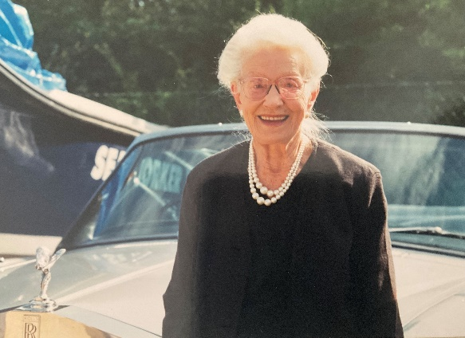
Mrs Nausicaa Pinckney – our ‘Fairy Godmother’.
We thought that the obvious site would be next to the that occupied by Lymington Sea Scouts with access to it from King Saltern Road. Plans were submitted, only to be objected to by Cllr Jean Vernon-Jackson, who lived opposite. It transpired that there was a covenant on the land which prevented any development until 2003. In any event, our application was refused by the Planning Committee in January 1991 on the grounds that our proposal was contrary to the policies of the South-West Hampshire Structure Plan and the Coastal Towns Local Plan.
We returned to Mrs Pinckney and having explained the situation she immediately suggested the land at the eastern end of her property. Alec and I thought this much more suitable, providing we could get permission to access it from the car park. After viewing the site, we both thought if the original area we had suggested were to be increased by fifty per cent in width, it would create more possibilities, and rather cheekily we put this to her. At her request I marked out the proposed revised boundary with posts and string for her approval, which she happily gave, suggesting increasing the original price pro rata. And so, on the 6th of February 1992, for £1,800 the club acquired the freehold of the stretch of land from the bottom of the seawall to the back of the neighbouring properties in King Saltern Road. Unfortunately, before the sale went through, the Royal Lymington Yacht Club had approached Mrs Pinckney to request some land for themselves. She rang us to see if we would mind letting them have some of ours. It would have been churlish for us to have refused her request after all she had done for us. The deeds were eventually drawn up and kept with the solicitors Moore and Blatch.

CHAPTER FIVE
Planning Permission at Last!
That we would get planning permission for premises on the land was not certain and we owe a great deal to our past president Reg Penny for making it happen. Thirteen members of the planning committee met on the sea wall one evening to debate our new application and finally agreed to our proposal, Full planning permission was granted on the 10th of July 1991. As the reedbed behind the clubhouse lay within a Conservation Area it had to remain untouched. This was no great hardship as it is very boggy; in fact, it now serves as a nature reserve. Further good news followed when the Council agreed to us having a permanent right of way from the car park to our land for £500.
Now we had the permission, the drive was now on for someone to clear the land and build us the clubhouse within our budget; three tenders were drafted and sent out for quotes. Of the three received none came anywhere near what monies we had available at the time after purchasing the land. The best quote was just under £70k from Freemantle Contractors Ltd, a local building company. This proved in time to be the right builder: not only for price but also the flexibility to negotiate on whatever our changing needs were, with no detrimental effect upon what had been agreed within our tender. Now the need was on as to how are we going to raise the extra revenue to pay for it all!
CHAPTER SIX
Fund Raising
We now at least had something realistic to aim for after 30 years and we accordingly looked at ways and means of providing the additional funds. While Alec dealt with all matters pertaining to planning, it left me free to concentrate on applying for grants and fund-raising. As Treasurer, I sent out approximately 200 letters for financial help to councils, companies, organizations etc., to try and raise the required revenue. The letters went out with the hope that something would come of it all and help us in our quest for funds. Of the total that were sent, only a small proportion replied, but at least some did produce the following good results: New Forest Council £15,000; Hampshire County Council £4,000; Hampshire Playing Fields Association £1,000 (subject to disabled facilities being provided); Lymington Town Council £750; and Lymington Yacht Haven £200. We were still short of our total, but after one of our committee meetings, Chris Clark approached me and said he was willing to loan the club £15,000 towards the total, to which I said I could also loan £5,000 on the same basis. Both were repaid over a 5-year interest free period.
At this point we were so close to our goal that we tried everything in our power to take care of the shortfall, which was in the region of £3-5,000. This became possible by raising it in the following ways.
- Negotiating with the builder items in the contract that we could manage ourselves to save costs.
- Donations from members via schemes such as ‘Buy a brick’, special ten-year membership deals.
3. Additional fund raising e.g., draws etc.
4. Finding volunteers within the club able to carry out work.
5. Appeals for donated materials or available at cost price or less.

By initiating these five ways of fund raising, the total was achieved, and Freemantle was awarded the contract.
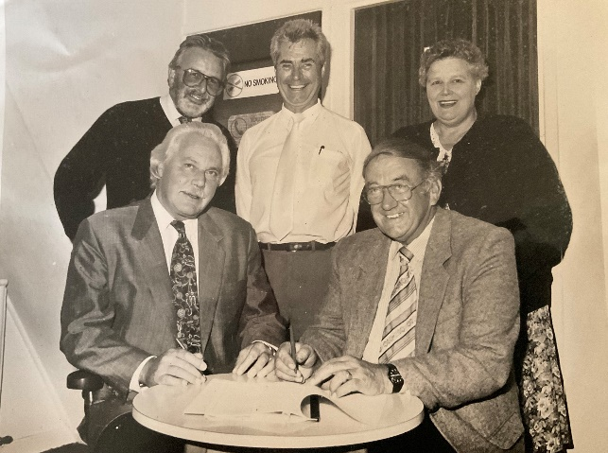

Signing the contract with Freemantle Contractors. Left to right back row: Mike Finch (estimate surveyor), Ray Davies (Club Treasurer), Mrs Georgina Moody (Hon. Club Secretary). Left to right front row: Eric Hall (Freemantle Contractors) and Gerald Ashton-Smith (Chairman).

After work had begun, during the clearing of the land, I had a call from the digger driver on site to say that in clearing soil he had uncovered a bomb and what should he do? I immediately asked him to stop work and went to investigate. He certainly had uncovered what looked like a bomb and I immediately informed the police, by which time pandemonium had broken loose. The Portsmouth bomb squad was called, the I O W ferry was stopped, people and cars also. It turned out to be a practice bomb dropped in the last war. It was removed and work resumed.

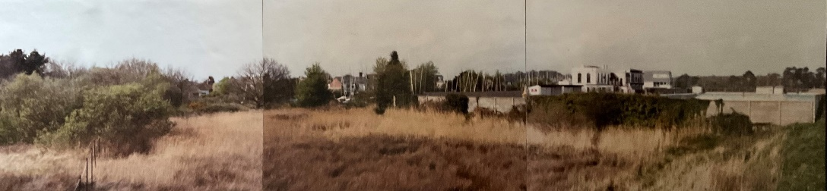

View of land from the seawall before commencement of construction.

The following are just some examples of what took place in raising the remaining shortfall. Included in their contract, Freemantle had to dig a service trench from the council toilet block in Bath Road car park to lay on the water and waste services and at no extra cost they agreed to lay a 3-phase electric cable which I donated. In addition, again at no extra cost to us they constructed a small brick enclosure next to the toilet block for our electrical connections and meter. Alec Harmer donated £250 for the special bricks for the windowsills, Robin Lane helped his electrician friend Gary Lancaster in wiring the building and providing furniture from the local tip, Rodney Saunders and I put the ceiling up, Chris Biddlecombe did the plumbing, Chris Clark supplied the terrazzo tiles, and Janet Littlefair made all the curtains. There were many other incidental jobs like tiling, rendering, plastering, and Artexing, which were carried out by friends, members, and colleagues, either free or at little cost as possible.

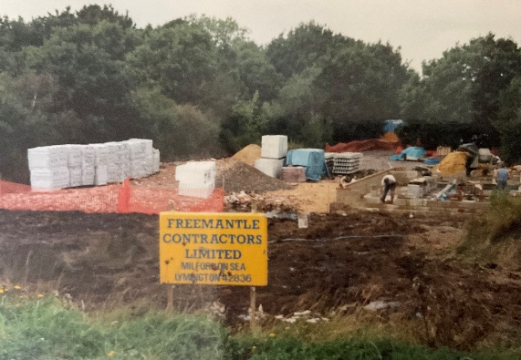
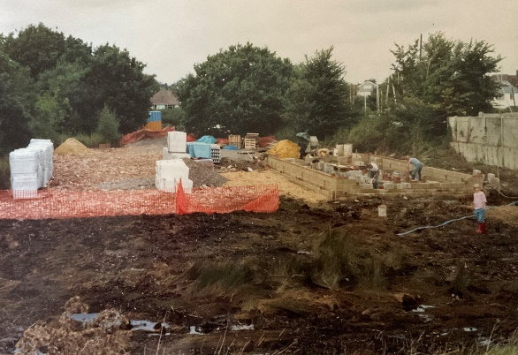
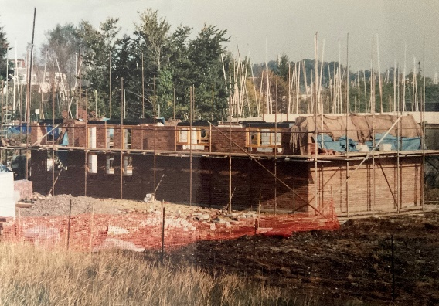
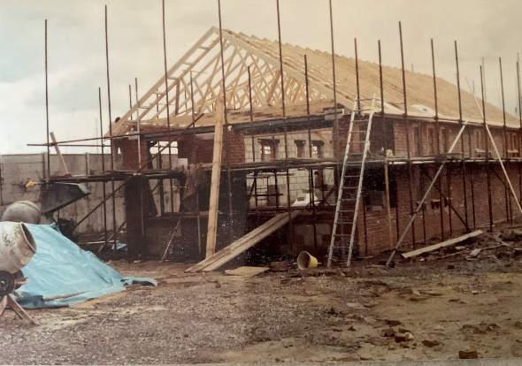
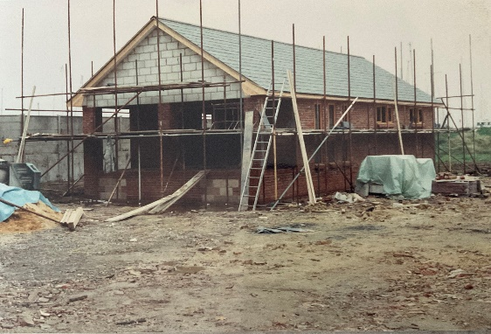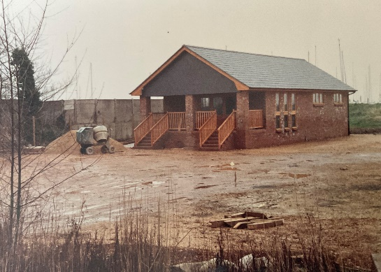
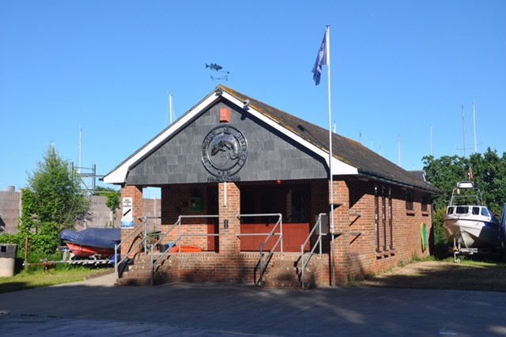

Various stages in the construction. The blue and yellow unit in the background of the first two photos was the Club’s customised Rollalong. It was towed out and used on the various club open competitions.
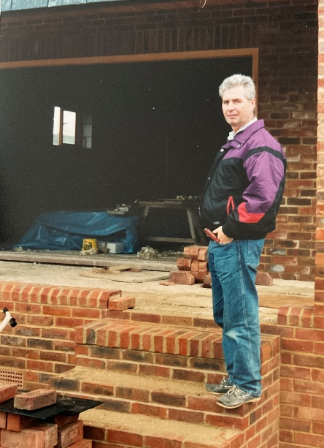

Ray Davies

CHAPTER SEVEN

The Grand Opening

By doing all of this and maybe more with the will and dedication, the clubhouse was officially opened on 28th August 1993 by Mrs Nausicaa Pinckney, who arrived in style, chauffeured by our president Reg Penny in his convertible Rolls-Royce! We will always be eternally grateful to her: for without her generosity that enabled us to purchase this prime parcel of land so close to the river at a peppercorn cost, this building and boat park would certainly not be here. I am pleased, too, that in some measure we have been able to repay her kindness. We have shared our good fortune by accommodating two other clubs in desperate need of facilities: SailAbility, and Barton Sea Scouts.

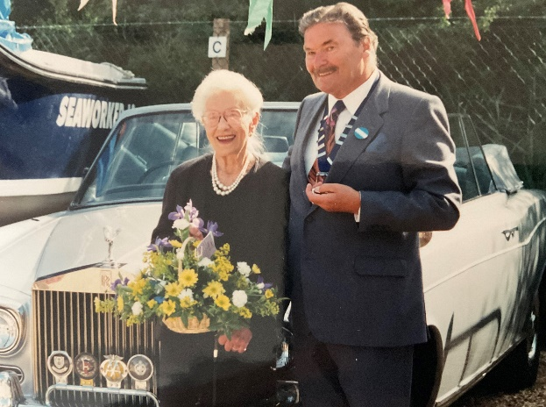

Mrs Pinckney and Reg Penny arriving in style!
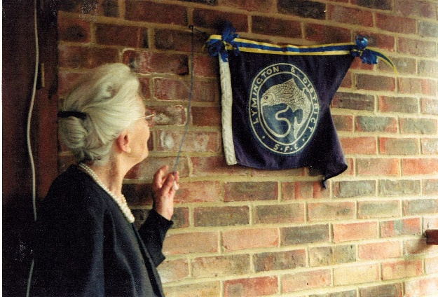

Mrs Pinckney officially opening the clubhouse.

Since its completion there has been several alterations and improvements over the years. In 2000 the original planning permission was altered to change the area designated as a car park into what is now the boat storage compound. The original weighing room was converted into the Gents toilets in 2004.
In 2012 temporary planning permission for a period of five years was granted for a former site office to be installed. When the term was up, a further temporary planning permission was refused and full planning permission was eventually obtained, conditional on the unit being upgraded with a pitched slate roof and vertical cladding. The cost of doing this was over £6000. The boat compound area was, not without its headaches, concreted over in 2012.
In Conclusion
We now have a well-established clubhouse that has been in use for the past 30 years; and which will hopefully continue to be used as time goes by for the benefit of the members and angling in general. It is important that the history of how, when, and the reason why it was built, is neither lost nor forgotten. The same applies to all those that took part in its original construction. None of this would have been possible without the help of many people such as Gerald Ashton-Smith, Kevin Barton, Chris and Tim Clark, Chris Ellis, Don Gaunt, Sass Gregory, Alec Harmer, Tony Humm, Robin Lane, George Monckton. Georgie and Sue Moody, Mike Prince, Rod Saunders, Bob Thompson, Peter Tybincowski, Wally Ward, and Geoff Wheeler. Not forgetting, too, the many non-members, wives/girlfriends etc., who gave their time/materials or money to help in whatever way possible; also, all those members long since departed, who over the years played their part in raising funds. One person I would particularly like to mention is the late Brian Down, a reporter for the Lymington Times and a staunch champion of our club. He ensured that we got plenty of press publicity throughout our long fight for premises.
As for myself, I hope I have managed here to record the vision that I, as a junior some sixty years ago, thought was needed. Hopefully, too, I have given everyone some idea of what took place, the effort that was made and finally how it all came to fruition . . . ‘The Phoenix really did rise from the ashes’! It only goes to show that with determination, dedication, and team spirit, and above all belief, that in time you can achieve your goals.
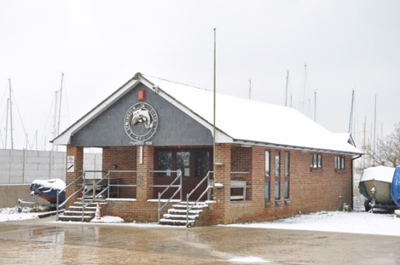
A Clubhouse for all Seasons
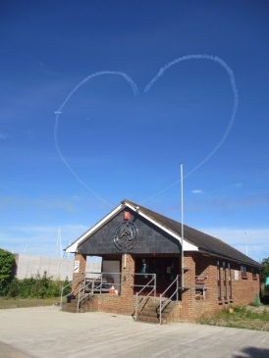
We love our Clubhouse

